**Quiz System**

Shubham Siloriya*| Hariom Mandloi*| Deepak Patel* | Deepak Patel*| Varsha Choudhary**

UG Scholar*, Supervisor**

Department of CSE (Data Science ), Acropolis Institute of technology and research, Indore(M.P)

***Abstract*— The Quiz System is a user-interactive application designed to facilitate the creation, management, and evaluation of quizzes in a digital environment. This system provides an efficient way for educators to assess learners, and for users to test their knowledge across various topics. The core functionality includes question management, user registration/login, quiz attempt, automatic scoring, and result display.**

# 

# INTRODUCTION

The Quiz System is a computer-based application designed to conduct quizzes in an efficient, accurate, and user-friendly manner. It replaces the traditional pen-and-paper method with a digital approach, allowing quizzes to be created, administered, and evaluated quickly. This

system is particularly useful in educational institutions, training programs, or any environment where knowledge assessment is needed. The main objective of this project is to provide a platform where users can attempt quizzes consisting of multiple-choice questions (MCQs), and receive instant results. Administrators can add or update questions, while users can select quizzes, answer questions, and view their scores immediately after submission. This not only saves time but also reduces manual errors in grading. Developed using [C language – update based on your project], the system emphasizes core programming concepts such as loops, arrays, conditional statements, and file handling. It features a simple text-based interface, making it easy to use eve

for beginners. The Quiz System project demonstrates how software can streamline routine tasks and improve learning outcomes. It also provides a foundation for

This project addresses the need for accuracy, speed, and ease of access in testing systems. It eliminates the manual effort required in traditional quiz formats and enables both students and instructors to benefit from quick assessments. Moreover, it serves as a foundational tool for understanding how real-world applications are built, tested, and improved using programming logic and structured design. time-limited quizzes, score tracking, and user authentication. As a minor project, it showcases practical application of programming knowledge in

a real-world scenario. In the digital age, the demand for automated testing and evaluation systems has grown significantly. A **Quiz System** serves as a modern solution for efficiently conducting online or offline assessments in a structured and reliable manner. This minor project aims to develop a quiz application that allows users to take multiple-choice quizzes and receive immediate feedback on their performance. It provides a platform that simplifies the tasks of quiz creation, question management, answer evaluation, and result generation. The system is developed using the **C programming language**, making use of fundamental concepts such as control structures, arrays, functions, and file handling. It offers a console-based interface where users can interact with the system through simple input and output operations. The program is designed to read and store quiz questions, allow users to attempt them, and calculate scores based on correct responses. This project addresses the need for accuracy, speed, and ease of access in testing systems. It eliminates the manual effort required in traditional quiz formats and enables both students and instructors to benefit from quick assessments. Moreover, it serves as a foundational tool for understanding how real-world applications are built, tested, and improved using programming logic and structured design.

# II. Objectives of the System

# To automate the quiz process

To automate the quiz process  
The system is developed to replace traditional, manual quiz methods with a computerized approach. This automation allows quiz organizers to easily create, store, and manage questions within the application. Users can then take quizzes directly through the system, without the need for printed question papers or manual checking. This reduces the workload of teachers and trainers and streamlines the entire assessment process.

* **To provide instant result generation**

One of the key advantages of the system is its ability to compute and display results immediately after quiz completion. Unlike manual checking, which is time-consuming and prone to delays, this system processes answers in real time and provides users with immediate feedback. This helps users quickly understand their performance and enables quicker decision-making for instructors.

* **To enhance learning through self-assessment**

The system allows users to take quizzes on various subjects at their convenience. This feature encourages self-learning and continuous improvement, as users can assess their knowledge, identify weaknesses, and work on them independently. It supports the learning process by providing a practical tool for revision and testing.

* **To reduce human error in evaluation**

Manual checking of answers can often lead to mistakes or inconsistencies. The Quiz System eliminates this issue by automatically verifying answers against the correct options stored in the system. This ensures that scoring is fair, accurate, and consistent across all users.

* **To implement core programming concepts**

This project offers students a valuable opportunity to apply theoretical knowledge of programming to a real-world problem. The system involves important concepts such as arrays for storing data, loops for repetition, conditionals for decision-making, and file handling for storing questions and results. It enhances problem-solving skills and provides hands-on experience with structured programming.

* **To offer a user-friendly interface**

The system is designed with simplicity in mind so that users can easily interact with it using basic keyboard input. Clear instructions and intuitive prompts guide users through the quiz-taking process, making the system accessible to users with minimal technical knowledge.

* **To support future enhancements and scalability**

The project is structured in a modular fashion, meaning new features can be added without having to rebuild the system entirely. This includes adding functionality such as user accounts, password protection, timed quizzes, category-wise questions, and leaderboard tracking. The flexible design ensures that the system can grow to meet future requirements.

* **To ensure data storage and retrieval for future reference**

The Quiz System is designed to store quiz questions and user scores using file handling techniques (or database

integration, if applicable). This ensures that data such as questions, options, correct answers, and user results can be saved and accessed later. It allows instructors to reuse question sets, analyze user performance over time, and maintain records for academic or training purposes.

# III. Literature Review

# The advancement of technology has significantly transformed educational tools and learning methods, leading to the development of digital quiz systems aimed at improving assessment and self-evaluation. Traditional pen-and-paper quizzes, while still in use, are increasingly being replaced by automated systems that offer greater efficiency, accuracy, and accessibility. Several studies and projects have explored quiz systems as an effective tool for academic evaluation, highlighting their ability to provide real-time feedback, reduce human error, and enhance user engagement. According to research in educational technology, computer-based testing systems have shown to improve learning outcomes by enabling regular self-assessment and timely feedback. These systems also contribute to eco-friendly practices by reducing paper usage. Various programming languages and technologies have been used to implement quiz systems, such as C, Java, Python, and web technologies (HTML, CSS, JavaScript), each demonstrating different approaches in terms of data storage, user interface, and scalability. Open-source and commercial quiz platforms, such as Google Forms, Kahoot!, and Moodle Quiz, have set a standard in terms of interactive design and functionality. These tools emphasize the importance of question randomization, user authentication, time-bound quizzes, and result analysis—features that inspire the continuous improvement of academic quiz applications. This project builds upon these existing ideas by developing a simple, console-based quiz system using [C language], focusing on the core functionalities such as question presentation, user interaction, scoring, and file handling. The review of previous systems has influenced the modular structure of this project and highlights areas for future enhancement, such as database integration and graphical user interfaces. In recent years, educational technology has made significant strides in developing automated assessment tools that streamline the process of evaluating learners.

**IV. System Overview**

* Functional Requirements

The Quiz System must support a variety of core functions to fulfill its purpose effectively. Firstly, the administrator should be able to add multiple-choice questions, each containing a set of four options along

with the correct answer. These questions must be stored using file handling so they can be retrieved when needed during the quiz session. The system should allow users to start the quiz and present the questions one at a time in a clear and readable format. For each question, the user must be able to input their answer by selecting one of the given options. Once the user completes the quiz, the system should automatically evaluate the responses, compare them with the correct answers, and calculate the total score. After the evaluation, the system should display the result, including the user's score and possibly feedback on their performance. Additionally, the application should include the ability to exit the quiz at any stage through a clear and safe exit command. These functionalities ensure that the quiz system operates efficiently and provides a seamless experience for both administrators and users.

* Non-Functional Requirements

In addition to the core functionalities, the Quiz System must meet several non-functional requirements to ensure it operates effectively and provides a satisfactory user experience. The system should be highly usable, featuring a simple, text-based interface that is easy to navigate even for users with limited technical skills. It must be reliable and capable of running smoothly without crashing or producing errors during the quiz session. Portability is also important—the program should be compatible with any operating system that supports the C programming language, such as Windows or Linux. The system must perform efficiently by loading questions, accepting inputs, and displaying results quickly, regardless of the number of questions involved. Maintainability is another key requirement; the codebase should be modular and well-organized, making it easy for future developers to modify, update, or expand the system. Lastly, the system must ensure data integrity by accurately storing and retrieving questions and user responses, preventing data loss or corruption during file operations. These non-functional aspects play a crucial role in determining the overall quality, robustness, and sustainability of the application.

**V. Technical Architecture**

The technical architecture of the Quiz System defines the structural design and interaction between different components of the system. It is a simple, layered architecture that follows a modular approach using the C programming language. The system runs as a console-based application, and the key layers involved are as follows:

1.Presentation Layer (User Interface)

This layer handles all user interactions. It displays questions, instructions, menus, and results using standard input/output functions (printf and scanf). It also takes user input, such as quiz responses or menu selections. Since this is a console application, the interface is text-based and easy to operate, even in low-resource environments.

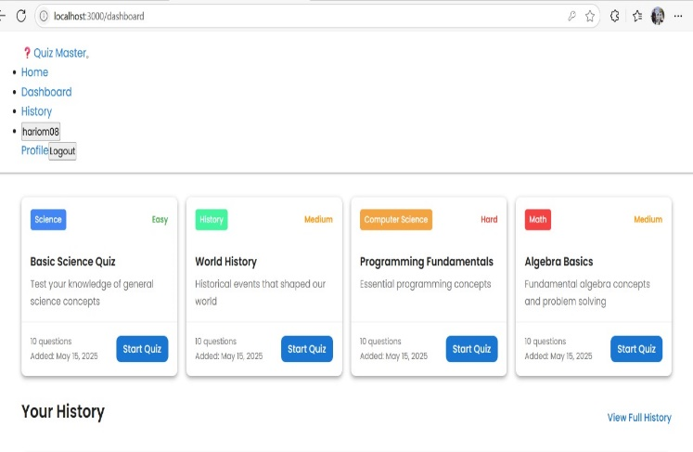

Fig 1.1 User Interface

2. Application Logic Layer (Business Logic)

This layer contains the core functionality of the quiz system. It includes:

* Logic to load questions from files
* Logic to present questions one by one
* Answer validation and score calculation
* Conditional structures to evaluate user input

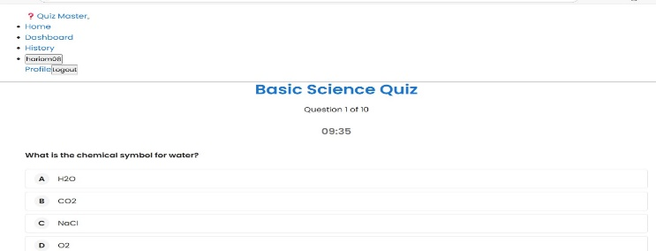

Fig 1.2 Questions

3. Data Layer (File Handling and Storage)

This layer is responsible for managing persistent data. It uses file handling in C (fopen, fprintf, fscanf, etc.) to store:

* Quiz questions and options
* Correct answers
* User scores or result summaries

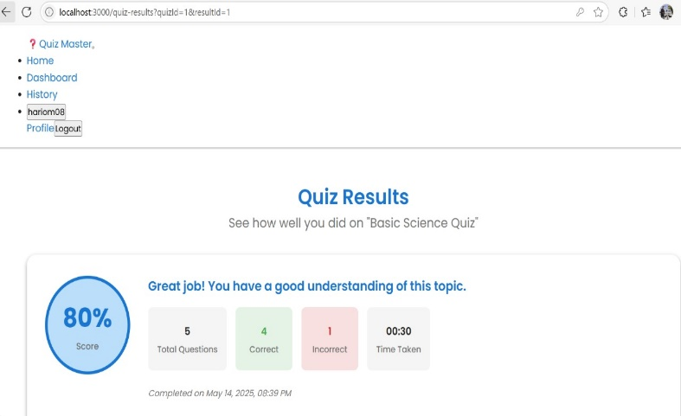

By storing data in files (e.g., .txt files), the system avoids the need for databases, making it lightweight and easy to deploy.

TechnologyStack Used

* Programming Language: C
* Compiler: GCC (or any standard C compiler)
* Platform: Cross-platform (Windows/Linux with terminal)
* Storage: Text files using file handling
* Interface: Text-based (command line)

Architecture Flow (Simplified Steps)

1. Start program ➝ display main menu
2. Load questions from file
3. Display questions and collect answers
4. Validate answers and calculate score
5. Display final result
6. Exit or restart quiz

KeyCharacteristics

* ModularDesign: Separates UI, logic, and storage.
* Portable: Can run on any system with a C compiler.
* Lightweight: No need for external libraries.

**VI. System Implementation**

The implementation of the Quiz System involves translating the system design into a working software application using the C programming language. The system is developed in a console-based environment and follows a modular approach, ensuring that each function blocks of code (functions). The implementation phase focuses on core programming concepts such as loops, conditionals, arrays, functions, and file handling. The implementation begins with the setup of the main menu, where users can choose between starting the quiz, viewing instructions, or exiting the program. When the user selects to begin the quiz, the system loads questions from a pre-created text file using file handling functions like fopen(), fscanf(), and fgets().Each question is displayed one by one, along with four options. The user inputs their answer (e.g., A, B, C, or D), and the system stores this input in memory. The program then compares the user's response with the correct answer stored in the file and calculates the score accordingly. At the end of the quiz, the total score is displayed along with optional feedback like pass/fail status. The filesystem plays a crucial role in the implementation. All questions, options, and answers are stored in a structured format in a .txt file. This allows the quiz to be easily updated or extended without changing the main code.

**VII. CONCLUSION**

The Quiz System developed using the C programming language successfully fulfills the core objectives of creating an interactive, user-friendly platform for conducting

multiple-choice quizzes. Through this project, key programming concepts such as file handling, arrays, loops, and functions were effectively applied to design a modular and efficient application. The system provides a straightforward way for users to attempt quizzes, receive immediate scoring, and view their results. Although simple in design, the project demonstrates the practical use of fundamental programming techniques and lays the groundwork for further enhancements. Future improvements can include adding a graphical user interface, implementing user authentication, and integrating database support for better data management.

**VIII. REFERENCES**

[1] Moodle Documentation – Moodle Quiz Module, https://docs.moodle.org

[2] Google Forms Help – Create a quiz with Google Forms, https://support.google.com

[3] Black, P., & Wiliam, D. (1998). Assessment and classroom learning. Assessment in Education: Principles, Policy & Practice, 5(1), 7–74.

[4] Anderson, L. W., & Krathwohl, D. R. (2001). A Taxonomy for Learning, Teaching, and Assessing: A Revision of Bloom's Taxonomy of Educational Objectives.

[5] Kahoot! – Game-based learning platform, https://kahoot.com